Test Project Module 2
(Editorial)

WSC2013_TP40_M1_actual_EN

Submitted by: Group 2

Arnold Sandjaja ID
Christoph Elmecker AT
Hee Min Sa KR
Hjortur Gudnason IS
Katsuji Hirata JP
Michel Bulon CA
Nuno Viana PT

Introduction to test project documentation

Contents
This Test Project proposal consists of the following documentation/files:

- WSC2013_TP40_MOD02_actual_TP_EN.doc
- WSC2013_TP40_MOD2_PRE_EN_images (Images Folder)
- WSC2013_TP40_MOD2_PRE_EN_ATTAC_logo (ATTAC Logo Folder)
- WSC2013_TP40_MOD2_PRE_EN_BARCODE.eps
- WSC2013_TP40_MOD2_PRE_EN_TEXT_FILES.docx

Introduction

Project :
Task 1: Entwickle für die Organisation ATTAC einen Magazine_Titel für die Zeitschrift „SPANNER in the works“
Task 1: Create a masthead for the magazine with the name “SPANNER in the works” for the organisation ATTAC
Task 2: Gestalte die Zeitschrift „SPANNER in the works“
Task 2: “Design a magazine SPANNER in the works

Description :
ATTAC ist eine internationale Organisation, welche in der Anti-Globalisierungsbewegung aktiv ist. Sie ist gegen neoliberale Globalisierung und zeigt soziale, ökologische und demokratische Alternativen auf, um die grundlegenden Rechte der Menschen für alle zu gewähren. Im Einzelnen kämpft ATTAK für die Regulierung der Finanzmärkte, die Schließung der Steueroasen, die Einführung von weltweiten Steuern um öffentliche Güter zu schützen/finanzieren, die Erlassung der Schulden für Entwicklungsländer, fairen Handel und die Einführung von Grenzen für den freien Handel und den Finanzstrom.
ATTAC is an international organization involved in the alter-globalization movement. We oppose neo-liberal globalization and develop social, ecological, and democratic alternatives so as to guarantee fundamental rights for all. Specifically, we fight for the regulation of financial markets, the closure of tax havens, the introduction of global taxes to finance global public goods, the cancellation of the debt of developing countries, fair trade, and the implementation of limits to free trade and capital flows.

Ein paar Worte zu unserer Geschichte | A word on our history

The ‘Association pour la Taxation des Transactions financière et l'Aide aux Citoyens’ (Association for the Taxation of financial Transactions and Aid to Citizens) wurde in Frankreich im Dezember Jahre 1998 gegründet. Dies geschah nach der Publikation „the Monde Diplomatique of an editorial entitled ‘Désarmer les marchés’ (Disarm the markets)“
The ‘Association pour la Taxation des Transactions financière et l'Aide aux Citoyens’ (Association for the Taxation of financial Transactions and Aid to Citizens) was founded in France in December 1998 after the publication in the Monde Diplomatique of an editorial entitled ‘Désarmer les marchés’ (Disarm the markets) that launched the notion of creating an association to promote the Tobin tax.

Eine Internationale Organisation | An international organization
Die Organisation entwickelte sich sehr schnell rund um die Welt mit einem ATTAC Netzwerk und der Internationalen Charta von 1999. Heute zählt die Organisation 40 aktive Länder mit über Tausend lokalen Gruppen und hunderten weiteren Vereinigungen, welche das Netzwerk unterstützen.
The organization expanded very rapidly around the world with an ATTAC network around an international charter set up in 1999. Today, the association is active in some 40 countries, with over a thousand local groups and hundreds of organizations supporting the network.

Zielgruppen | Target market:
Junge Leute zwischen 16 und 35 Jahren, welche Interesse an der Anti-Globalisierungsbewegung zeigen. Sie sehen Werte wie Demokratie, soziale und wirtschaftliche Gerechtigkeit, Umweltschutz und Menschenrechte als Alternative zur gegenwärtigen Globalisierungstendenz an.
Diese Menschen sind entweder schon Mitglieder von ATTAC oder denken über eine Mitgliedschaft nach.
Young people between 16-35 years who are interested in the alter-globalization movement, which emphasizes values such as democracy, social and economic justice, environmental protection and human rights as an alternative to the current globalism.
They are either a member of ATTAC or are thinking of joining.

Description of project and tasks

TASK 1
Creation of a masthead
- Entwickle einen Magazine – Titel mit dem Wort “SPANNER” und dem Untertitel „in the works“
- Create a masthead and use the name “SPANNER” with the subhead “in the works”.
- Du kannst frei eigene Elemente oder Illustrationen hinzufügen.
- You are free to add any elements or illustrations of your own to the masthead.

Technical specifications

Trapping : 0.35 pts (if necessary).
Printing : Sheet-fed offset.

You must deliver
- 1 version of the masthead in exactly 2 PMS C colours in eps or AI format
- 1 version of the masthead converted to CMYK in eps or AI format
- 1 version of the masthead in Adobe RGB (1998) for the web in JPG format
- 1 file PDF/X-4:2008 file of the masthead in CMYK on one single A4 sheet at both 15cm wide and 4cm wide (without any marks, bleed or colour bars)
- 1 Printout masthead and mounted on cardboard from the CMYK PDF/X-4:2008 file

TASK 2
Magazine Design
- Create a design for the front cover, back cover and spine
- Create a design for page 3 of the magazine accommodating for the die-line of the cover

- Create two spreads for the magazine (pages 8&9, 10&11)
- Include required text in the magazine (WSC2013_TP40_MOD2_PRE_EN_TEXT_FILES.docx)

- You must create a die-line for the cover
- The inside pages of the magazine will be printed in 2 colours (Black and PMS 7549 C)
- Include the barcode with a white background; do not resize it and make sure it’s 100% black (WSC2013_TP40_MOD2_PRE_EN_BARCODE.eps)
- You may create your own illustrations

Front Cover must include:
- Masthead
- Selling Line
- Logo %ATTAC

- Main cover line
- image (at least one)
- 3
- Cover lines
- Dateline
- Barcode
- Splash/ Seal/ Flash/ Slashes

- Any other artwork you deem necessary

Back Cover must include:
- The logo at exactly 35mm wide
- Text for back cover
- Any other artwork you deem necessary

Spine must include:
- Text for spine

Inside pages of the magazine must include:

- Page 3: Single page must display an editorial with titles, texts, and caption (at least 1 image and any other artwork you consider necessary)
- Page 8-9: One spread must display the cover story and some images of the cover story (at least 2 images) with titles, texts, captions, 1 table and 1 infographic
- Page 10-11: One spread must display three short articles with titles, texts, and captions (at least 1 image for each article)

Technical specifications
Dimensions : A maximum page size of 190mm x 270mm (portrait) perfect bound with a 6 mm spine.
Paragraph Styles : Must be used for titles, body text, caption
Character Styles : Must be used for coverline, Dateline
Master Page Elements : Header/footer and page numbers
Bleed : 3 mm
Colours (Front, spine & Back cover) : CMYK, spot dieline

Colours (inside pages of magazine) : 2 colours (PMS 7549 C and Black)
Output ICC profile in PDF : ISO Web coated FOGRA28 /Total ink 300% (front & back Cover) 200% (inside pages of magazine)
Printing system : Heatset web offset
Dieline : Must be named “Dieline”, must be created as a spot colour and must overprint
Greyscale and colour images resolution : 262 to 350 PPI at 100% in InDesign
Bitmap images resolution : 800 to 1200 PPI at 100% in InDesign

You must deliver

• 1 final folder for archiving named with your competitor number_module1
(including native files, fonts, linked images, ICC profile and the press ready PDF/X1a file)
only files from this folder will be marked

• 2 final press ready PDF/X1a files (1 PDF for cover, spine and back cover; and 1 PDF for inside pages, including: bleed, crop marks, registration marks, fold marks — placed outside the bleed area, colour bars for CMYK, colour bar PMS C, dieline on a separate plate in the PDF, to be evaluated in the PDF file)

• 1 final printout untrimmed and mounted on cardboard : the front cover, spine and back cover with the die-line (printed as spreads). (including: bleed, crop marks, registration marks, fold marks — placed outside the bleed area, colour bars CMYK)

• 1 final printout of: the die-line (printed as spreads). (including:, crop marks, registration marks, fold marks — placed outside the bleed area)

• 1 final dummy/booklet trimmed to final size including:
- the front cover, spine, back cover printed as spreads
- 1 page printed as a single page (page 3)
- four pages printed as spreads (8-9 and 10-11)

Instructions to the competitor
Create a folder on your Desktop called YY_MODX (where YY represents the number of your workstation). This folder must include the following subfolders:

- Original_folder: it should contain all the files used for the development of your project, properly organized (fonts, links, etc.).
- Final_folder: it should contain all the files you are supposed to deliver as required in the tasks (PDF, etc.).

About image marking for the tasks:
The colour mode and file formats of your images will be evaluated in the press ready PDF files. The final resolution will be assessed in the InDesign file.

The JPG file format is NOT ACCEPTED for images; except for the web component of the logo in RGB for the web.
Only the following file formats are acceptable .TIF / .EPS / .AI / .PSD / DSC 2.0

About final design marking for the catalogue:
The task must be created in a page layout program (Adobe InDesign).
Images must not be embedded or placed in Adobe Illustrator or embedded in InDesign

Any file saved out of its respective folder WILL NOT BE EVALUATED.

Marking scheme
A | Creative process |  | Subjective /2
A.1 | Idea and originality (masthead, dieline and magazine) |  | 1.00
A.2 | Understanding the target market (masthead, dieline and magazine) |  | 0.50
A.3 | Unity and relationship (masthead and magazine) |  | 0.50
B | Final design |  | Subjective /8
B.1 | Quality of the visual composition (masthead and magazine layout) |  | 1.00
B.2 | Impact of the design (masthead, magazine layout and usage of font) |  | 1.00
B.3 | Quality of the typography for the masthead |  | 1.00
B.4 | Quality of the typography for the magazine |  | 2.00
B.5 | Quality of the colours for the masthead |  | 0.75
B.6 | Quality of the colours for the magazine |  | 1.25
B.7 | Quality of the design & originality of other elements (choice of page size & master page elements) |  | 0.50
B.8 | Quality of the infographic (magazine page 8 or 9) |  | 0.50
C | Computer usage |  | Objective /4
C.1 | Resolution of linked images as specified in magazine marked in InDesign |  | 0.50
C.2 | Colour mode of linked images as specified in magazine |  | 0.75
C.3 | Logo and barcode dimensions as required in the task |  | 0.25
C.4 | Use of paragraphs styles & master pages in layout as specified in magazine |  | 1.00
C.5 | Use of Character Styles in layout as specified in magazine |  | 0.25
C.6 | Final dimensions of layout as specified in all tasks (masthead, spine, inside pages) |  | 0.50
C.7 | All required text is present (masthead and inside pages) |  | 0.50
C.8 | All required elements are present in both tasks |  | 0.25
D | Manual abilities |  | Objective /2
D.1  D.2 | Mounting printouts for presentation  Mounting printouts for presentation and dummy |  | 1.00  1.00
E | Knowledge of the printing industry |  | Objective /4
E.1 | Bleed value applied in PDF |  | 0.25
E.2 | Fold lines, crop mark, colour bars & registration marks supplied in PDF |  | 1.50
E.3 | Trapping values applied in illustrator file if necessary (masthead) |  | 0.50
E.4 | Correct spot & CMYK colours used and supplied in PDF file as specified in magazine |  | 1.50
E.5 | Colours used in the masthead |  | 0.25
F | Saving and file format |  | Objective /5
F.1 | All files saved in the correct format (masthead and magazine) |  | 1.00
F.2 | ICC profile applied in images, PDF or layout file as specified in the task |  | 2.25
F.3 | Saving in a specified PDF format as required in the task |  | 1.00
F.4 | Final production folder saved as required in the task |  | 0.75

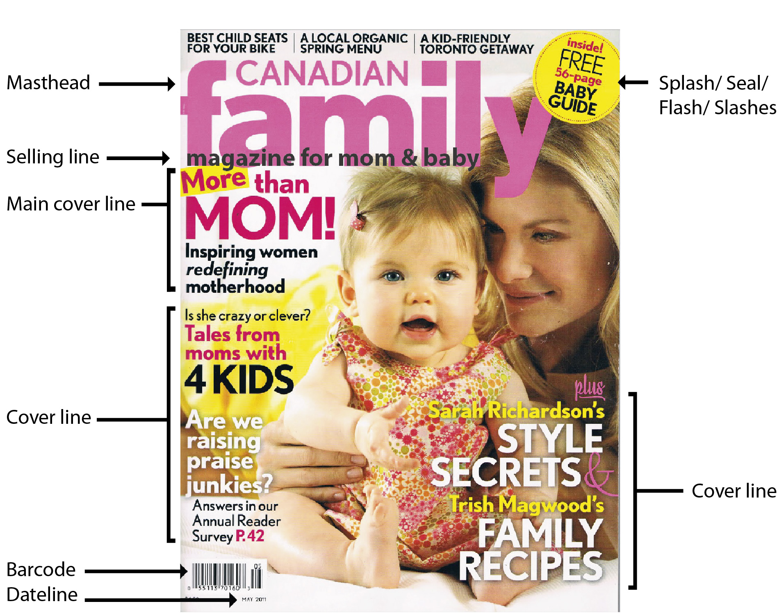

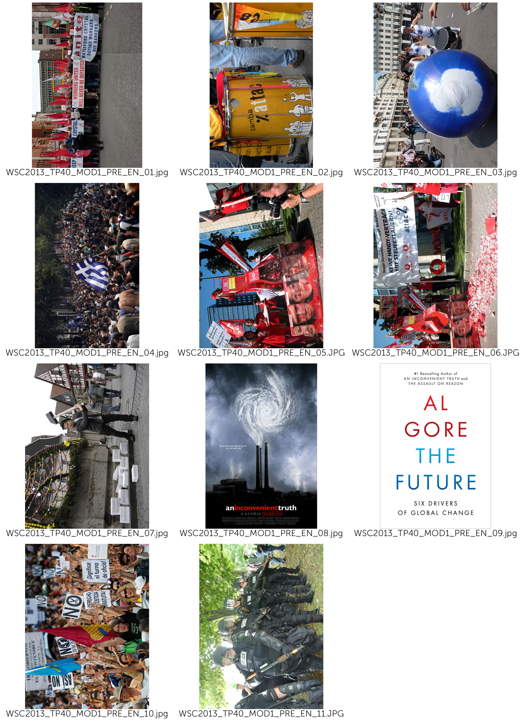
(- COVER)
(use picture at your choice:
- WSC2013_TP40_MOD1_PRE_EN_01.jpg
- WSC2013_TP40_MOD1_PRE_EN_02.jpg
- WSC2013_TP40_MOD1_PRE_EN_03.jpg)

(– Masthead )

SPANNER in the works

(– Selling Lines )

News magazine of ATTAC network

(– Main Line Cover)

Global Tax Justice:
If everybody shares the burden, no one suffers

(– Cover Lines)

Fiscal and Economic Union
The Future by Al Gore
For a Europe-wide coordinated levy on wealth

(– Date Line)

17 August 2013

(– Splash/ Seal/ Flash/ Slashes )

SPECIAL EDITION

(– Back Cover)
(use picture:
- WSC2013_TP40_MOD1_PRE_EN_07.jpg)

( Title: )

We fight for

( Main text: )
Attac sees the domination of financial markets on society as the main obstacle to the shift to a new mode of development that would be social, ecological, democratic, and relying on solidarity. In order to bring this domination to an end we demand:
• Limits to capital flow and regulations such as a tax on financial transactions so as to drastically reduce all speculative moves.
• The socialization of the banking sector so that the banks’ investment policies will be governed by social and ecological imperatives and not by short-term profits.
• The prohibition of any capital transit via tax havens to put an end to occult financial activities and to tax evasion.
• Restrictions to TNCs through international regulations.
• The cancellation of the public debt of developing countries.
• An increase in taxes on financial incomes and on private estates;
• A fair organization of international trade that is favourable to developing countries, wage earners, and the environment.
• Access to common goods of humankind (water, education, healthcare…) so that human rights are adhered to.
• Global taxes to finance access to common goods, namely taxes on TNC profits, polluting activities (carbon tax), on financial transactions, on large private estates.
• A social and ecological agriculture without GM, respectful of the principle of food sovereignty and making it possible for peasants to earn a decent living both in the North and in the South.
• Ways of solving conflicts peacefully (Attac favours non violence in its actions).
Attac also fights any extension of commodification, whether through privatization of public services, the development of pension funds, the privatization of social security, speculation on the right to pollute through a carbon market.

(– Master Pages)

SPANNER in the works

(– Page numbers )

3, 8, 9, 10, 11

(– Spine )

SPANNER in the works

17 August 2013

(– PAGE 3)

(Title: )
Our ideas

(Main text: )
Attac is a movement opposing neo-liberal globalization
Neo-liberal globalization, based on the ‘liberalization’ of trade and financial markets, started at the end of the 1970s and has led to the total domination of financial markets on society as a whole. It is an instrument designed to further the enrichment of a tiny minority of investors at the expense of the rest of the population and the planet. Its effects are detrimental to.

Social rights

neo-liberal globalization facilitates the shipping of businesses and jobs out of the country and fosters the worldwide competition between workers and, consequently, their precarization ;
It covers up tax evasion thanks to tax havens and sets in motion the competition between national tax systems and thus the reduction of public services.

The planet

Neo-liberal globalization makes it possible for transnational companies to spread their production on the surface of the globe based solely on costs, so that the various parts of a product can be manufactured at different locations on the planet, generating thousands of miles of transport;
It sets up a competition between national environmental regulations and thus pushes them to the lowest possible level;
It tends to commercialize all aspects of society and thus extends endlessly the consumer and growth society.

North South solidarity

As it organizes tax evasion, neo-liberal globalization imposes a new form of colonialism through corruption of elites in countries of the South;
Through free trade it imposes competition between farmers in the South and the large agro-business owners of the North ;
Via the debt mechanism, it allows the World Bank and the IMF to impose massive deregulation policies on developing countries.

Democracy

WTO, IMF, World Bank and the European Union set up new global economic rules outside any democratic debate: most international negotiations on trade or financial regulation occur away from the people; Neo-liberal globalization promotes the concentration of information dissemination in the hands of a few media and internet conglomerates.
The commercialization of all spheres of society reduces people to mere consumers at the expense of their citizenship.
And so, over the past 30 years we have witnessed a substantial enrichment of capital holders to the detriment of the vast majority of wage earners, together with a continued deterioration of the condition of our planet.
In the OECD countries, the proportion of wage earners in the producing sectors has declined by 10% while the return to capital has risen since the mid-1970s. In the United States, for instance, 60% of the growth recorded since 1980 has been captured by the wealthiest 1%.

(Caption for the pictures in this article : use picture at your choice:
- WSC2013_TP40_MOD1_PRE_EN_03.jpg
- WSC2013_TP40_MOD1_PRE_EN_05.jpg
- WSC2013_TP40_MOD1_PRE_EN_06.jpg)

Neo-liberal globalization promotes the concentration of information dissemination.

(– Pages 8 and 9)

(Title: )
Global Tax Justice:
If everybody shares the burden, no one suffers.

(Main text: )

How did this come about?

In the sixties and seventies capital was not very mobile, a tight net of capital transfer controls hampered the free flow of the deutschemark, schilling, pound etc. Due to this limited opportunities for capital flight taxation was reasonably fair. At this time the economy boomed, it grew faster than in the previous twenty years, full employment was close by and the differences in incomes began to shrink slowly. This scenario changed at the end of the seventies when neo-liberal politics like Thatcherism and Reaganomics got established worldwide. One of the core elements of neo-liberalism is the free flow of capital, but once capital is totally free to move it is difficult for Finance Ministers to tax it accordingly.

More and more Tax Havens

It gets even more difficult when, in the course of liberalisation, tax havens appear. You find tax havens not only in the Caribbean or Pacific (Bahamas, Samoa) but also right in the middle of Europe - Luxembourg, Liechtenstein, Monaco, Switzerland and Austria. In tax havens capitals gains and financial wealth are not only save from taxation, but the financial authorities in the countries of origin don´t get informed because of bank secrecy. The result is that the profiteers of globalisation contribute less and less to our common goods - hospitals, education, public transport, environmental protection, sport and culture.

Tax Competition Begins

Tax havens not only attract tax evaders, they also put pressure on other countries to reduce their tax rates on income, profit and wealth. In the last twenty years almost all countries have been competing in reducing taxes on income, profits, and capital gains. In the industrialised countries the average tax on business profits has dropped from 51% to 35% since 1985. Tax on interest yield from 47% to 33% and the top income tax bracket plummeted from 52% to 42%, and this process is by no means at an end. Indeed some economists consider that in the long run it won't be possible to tax profits at all. For some multinational corporations this is already the case - they file their profit tax returns in tax havens, they use tax loopholes or sometimes even manipulate their balance sheets. The result is they pay little or no tax where they are actually operating. Some examples for Austria: Creditanstalt (1998 and 99) the Spar AG (1997 and 98) and Shell Austria (1977) or the Immuno AG (1977). This is not just unfair for the community, but also for the small and midium sized businesses that can´t use these 'creative possibilities' and suffer under an unfair competitive disadvantage.

(Caption for the pictures in this article : use picture at your choice:
- WSC2013_TP40_MOD1_PRE_EN_01.jpg
- WSC2013_TP40_MOD1_PRE_EN_02.jpg
- WSC2013_TP40_MOD1_PRE_EN_03.jpg)

One of the core elements of neo-liberalism is the free flow of capital.

(- INFOGRAPHIC)

(title)
Reduction of tax rates on income, profit and wealth In the industrialised countries

(text)
The average tax on business profits has dropped
51% to 35%

Tax on interest yield
47% to 33%

The top income tax bracket plummeted
52% to 42%

(caption for infographic)
Since 1985

( -TABLE)

(title)
The multinational corporations who pay little or no tax

(text)
Company Year
Creditanstalt 1998,1999
Spar AG 1997, 1998
Shell Austria 1977
Immuno AG 1977

(caption for table)
Some examples for Austria

(– Pages 10 and 11)

(Title: )

The Future by Al Gore – review.

(Main text: )

Al Gore's alarming new guide to what needs to change in world politics is essential reading
According to reliable reports, the new leadership in Beijing has been reading Alexis de Tocqueville. It's not hard to see why China's elite might look for guidance to the aristocratic French thinker. In his classic text The Ancien Regime and the Revolution (1856), de Tocqueville wrote that the danger of revolution is not greatest in the depths of poverty and despair but when conditions have been improving – especially if some are benefiting far more than others. The relevance of this for China is obvious. The implications for policy are rather less so, since de Tocqueville also warned that for a bad government, the moment of greatest danger comes when it starts to reform. In such circumstances, repression might be a more prudent course of action. This troubling ambiguity could explain why Chinese readers, struggling to decipher the intentions of their rulers, made de Tocqueville's book a national bestseller.
From a parochial British perspective, what might be most significant is the fact that China's rulers are reading de Tocqueville at all. It is difficult to imagine David Cameron devoting any time to a 19th-century thinker. Along with much of the political class, the prime minister seems resistant to the notion that history has anything to teach, and looks for guidance to writers who extol the wisdom of crowds, explain the momentous importance of tipping points or pass on the revelation that humans are social animals – the fleeting nostrums of the airport bookstore. But if our rulers will not read the classics then they must read Al Gore, who, after eight years of reading and thinking, has produced a guide for the politically perplexed that will surely endure.

(Caption for the pictures in this article : use picture at your choice:
- WSC2013_TP40_MOD1_PRE_EN_08.jpg
- WSC2013_TP40_MOD1_PRE_EN_09.jpg)

The Cover of Al Gore’s Book, The future

(Title: )

For a Europe-wide coordinated levy on wealth

(Main text: )

The nature of the crisis
A constantly increasing disparity of wealth is an intrinsic aspect of capitalism. Wealth grows faster than workers’ income. Large amounts of wealth grow faster than small amount. In some countries, wealth taxes exist. But the tax rates are much lower than the growth rates of large fortunes. Therefore, strong political correctives to create a fairer distribution are necessary. This applies even more in the currently dominant form of capitalism driven by financial markets, since here the disparity in the distribution of prosperity has been growing especially rapidly. As this polarization of the distribution of wealth grows, so does the amount of capital circulating around the world in search of profitable investment opportunities. In particular since the 1970s, this mass has increased dramatically. It became less and less possible to exploit this capital profitably in the productive economy. In the search for new sources of profit, the international financial markets became more and more important. This transition was accompanied and fostered by constantly increasing deregulation and globalization of the financial markets, and led to a quite novel dynamism involving the polarization of the distribution of income and assets. The increasing dominance of the financial markets has allowed gigantic profits – and also losses – to be made within seconds. Thus the system is becoming more and more unstable. More and more speculative bubbles develop, which must burst sooner or later.

(Caption for the pictures in this article : use picture at your choice:
- WSC2013_TP40_MOD1_PRE_EN_10.jpg
- WSC2013_TP40_MOD1_PRE_EN_11.jpg)

A constantly increasing disparity of wealth is an intrinsic aspect of capitalism

(Title: )

Fiscal and Economic Union

(Main text: )

Fiscal pact, ESM, six-pack, two-pack
Under the pressure of the crisis, the powerful are pushing through their murky "reform" measures at a rapid pace. The logic is always the same: Reduce debts through cuts in social services and privatisation, raise competitiveness through wage cuts and eliminate workers rights. The consequences: A deep recession, further aggravating the economic crisis. In southern Europe the 'Troika' of the ECB, EU Commission, and the IMF dictate one so called Memorandum (austerity package) after another. The reality is a devastating social crisis. Mass unemployment, poverty, homelessness, soaring crime and waves of suicides are once again part of European everyday life. And "coincidentally" our democracies are being hollowed out: highly indebted countries are forced to transfer their sovereignty from their elected parliaments to the EU. Every day, the technocrats of the EU Commission and the ECB gain yet more power for themselves.
Can things get even worse, after all the reform packages so far that have established a neo-liberal, anti-democratic politics throughout Europe? Yes they can. In the European Council the introduction of a fiscal and economic union is being prepared right now. The diktat of austerity, through which Greece, Spain and Portugal suffer right now, will be institutionalised on the European level. Or as the European Commission President Barroso put it: A quiet revolution has been taking place.

(Caption for the pictures in this article : use picture:
- WSC2013_TP40_MOD1_PRE_EN_04.jpg)

In the European Council the introduction of a fiscal and economic union is being prepared.

